**Assignment 4**

PROG8170

Software Quality Assurance

School of Engineering and Information Technology

Conestoga College Institute of Technology and Advanced Learning

Submitted to Baljeet Bilkhu

Submitted by:

Chitmanjeet Singh Grewal (8250979)

Date:04/12/2018

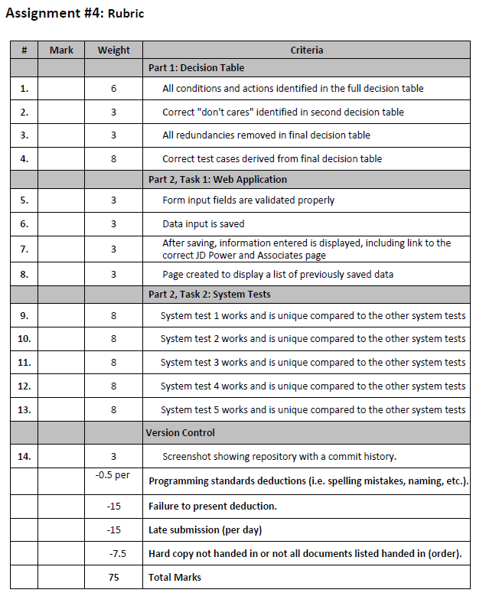

**Question 1:** Create a decision table based on this set of business requirements.

|  |  |  |  |  |  |  |  |  |
| --- | --- | --- | --- | --- | --- | --- | --- | --- |
| **STUB** | **ENTRY** | | | | | | | |
| 3 or More accidents | T | T | T | T | F | F | F | F |
| No Experience | T | T | F | F | T | T | F | F |
| If age >=30 and 2 years of experience | T | F | T | F | T | F | T | F |
| Provides Insurance |  |  |  |  | X | X | X | X |
| Annually $3000 |  |  |  |  | X | X |  |  |
| Annually $2000 |  |  |  |  |  |  | X | X |
| Annually $1000 |  |  |  |  |  | X |  | X |
| 20% off on base rate |  |  |  |  |  |  | X |  |

**Question 2:** Create a second decision table, removing items that don't matter with "don't cares".

|  |  |  |  |  |  |  |  |  |  |  |  |  |
| --- | --- | --- | --- | --- | --- | --- | --- | --- | --- | --- | --- | --- |
| **STUB** | **ENTRY** | | | | | | | | | | | |
| Experience | >=2 | <2 | 0 | | >9 | | >=2 | <2 | 0 | | >9 | |
| Accidents | < 3 | | | | | | >=3 | | | | | |
| Age | >=30 | <30 | >=30 | <30 | >=30 | <30 | >=30 | <30 | >=30 | <30 | >=30 | <30 |
| Provides Insurance | X | X | X | X | X | X |  |  |  |  |  |  |
| Annually $3000 |  |  | X | X |  |  |  |  |  |  |  |  |
| Annually $2000 | X | X |  |  |  |  |  |  |  |  |  |  |
| Annually $1000 |  |  |  |  | X | X |  |  |  |  |  |  |
| 20% off on base rate | X |  |  |  | X |  |  |  |  |  |  |  |

**Question 3:** Create a final decision table by removing redundancy.

|  |  |  |  |  |  |  |  |  |  |  |  |  |
| --- | --- | --- | --- | --- | --- | --- | --- | --- | --- | --- | --- | --- |
| **STUB** | **ENTRY** | | | | | | | | | | | |
| Experience | >=2 | <2 | 0 | | >9 | | >=2 | <2 | 0 | | >9 | |
| Accidents | < 3 | | | | | | >=3 | | | | | |
| age | >=30 | na | na | na | >=30 | na | na | na | na | na | na | na |
| Provides Insurance | X | X | X | X | X | X |  |  |  |  |  |  |
| Annually $3000 |  |  | X | X |  |  |  |  |  |  |  |  |
| Annually $2000 | X | X |  |  |  |  |  |  |  |  |  |  |
| Annually $1000 |  |  |  |  | X | X |  |  |  |  |  |  |
| 20% off on base rate | X |  |  |  | X |  |  |  |  |  |  |  |

**Test cases:**

Test case 1:

Input: New driver

Expected result: Insurance offered at $3000 per year.

Test case 2:

Input: Driver with 10 years experience, age 30 years.

Expected result: Insurance offered at $2000 per year.

Test case 3:

Input: Driver with 2 years experience, age 29 years.

Expected result: Insurance offered at $2000 per year.

Test case 4:

Input: Driver with 1 year experience, age 28 years.

Expected result: Insurance offered at $2000 per year.

Test case 5:

Input: more than 3 accidents.

Expected result: Insurance refused.

Test case 6:

Input: Driver with 3 years experience, age 23 years.

Expected result: Insurance offered at $2000 per year.

Solution:

using System;

using System.Collections.Generic;

using System.Linq;

using System.Text;

using System.Threading.Tasks;

using NUnit.Framework;

using OpenQA.Selenium;

using OpenQA.Selenium.Firefox;

using OpenQA.Selenium.Support.UI;

namespace assignment4

{

[TestFixture]

public class UntitledTestCase

{

[TestFixture]

public class InvalidContact

{

private IWebDriver driver;

private StringBuilder verificationErrors;

private string baseURL;

private bool acceptNextAlert = true;

[SetUp]

public void SetupTest()

{

driver = new FirefoxDriver();

baseURL = "https://www.katalon.com/";

verificationErrors = new StringBuilder();

}

[TearDown]

public void TeardownTest()

{

try

{

driver.Quit();

}

catch (Exception)

{

}

Assert.AreEqual("", verificationErrors.ToString());

}

[Test]

public void ContactNumberTest()

{

driver.Navigate().GoToUrl("http://localhost/index.php");

driver.FindElement(By.Id("Name")).Click();

driver.FindElement(By.Id("Name")).Clear();

driver.FindElement(By.Id("Name")).SendKeys("chitman");

driver.FindElement(By.Id("Address")).Clear();

driver.FindElement(By.Id("Address")).SendKeys("doon");

driver.FindElement(By.Id("City")).Clear();

driver.FindElement(By.Id("City")).SendKeys("kitchener");

driver.FindElement(By.Id("Phone")).Clear();

driver.FindElement(By.Id("Phone")).SendKeys("4568");

driver.FindElement(By.Id("Email")).Clear();

driver.FindElement(By.Id("Email")).SendKeys("cgrewal@gmail.com");

driver.FindElement(By.Id("Make")).Clear();

driver.FindElement(By.Id("Make")).SendKeys("Ford");

driver.FindElement(By.Id("Model")).Clear();

driver.FindElement(By.Id("Model")).SendKeys("Mustang");

driver.FindElement(By.Id("Year")).Clear();

driver.FindElement(By.Id("Year")).SendKeys("2011");

driver.FindElement(By.Id("btn")).Click();

Assert.AreEqual("Enter valid Phone Number", CloseAlertAndGetItsText());

}

[Test]

public void FormIncompleteTest()

{

driver.Navigate().GoToUrl("http://localhost/index.php");

driver.FindElement(By.Id("Name")).Click();

driver.FindElement(By.Id("Name")).Clear();

driver.FindElement(By.Id("Name")).SendKeys("chitmn");

driver.FindElement(By.Id("Address")).Click();

driver.FindElement(By.Id("Address")).Clear();

driver.FindElement(By.Id("Address")).SendKeys("cgrewal@gmail.com");

driver.FindElement(By.Id("Phone")).Click();

driver.FindElement(By.Id("Phone")).Clear();

driver.FindElement(By.Id("Phone")).SendKeys("24567897866");

driver.FindElement(By.Id("Email")).Click();

driver.FindElement(By.Id("Address")).Click();

driver.FindElement(By.Id("Address")).Click();

driver.FindElement(By.Id("Address")).Clear();

driver.FindElement(By.Id("Address")).SendKeys("doon");

driver.FindElement(By.Id("City")).Click();

driver.FindElement(By.Id("City")).Clear();

driver.FindElement(By.Id("City")).SendKeys("kitchener");

driver.FindElement(By.Id("Email")).Click();

driver.FindElement(By.Id("Email")).Clear();

driver.FindElement(By.Id("Email")).SendKeys("a@gmail.com");

driver.FindElement(By.Id("Make")).Click();

driver.FindElement(By.Id("Make")).Clear();

driver.FindElement(By.Id("Make")).SendKeys("ford");

driver.FindElement(By.Id("Model")).Click();

driver.FindElement(By.Id("Model")).Clear();

driver.FindElement(By.Id("Model")).SendKeys("mustang");

driver.FindElement(By.Id("Year")).Click();

driver.FindElement(By.Id("Year")).Clear();

driver.FindElement(By.Id("Year")).SendKeys("2013");

driver.FindElement(By.Id("City")).Click();

driver.FindElement(By.Id("City")).Clear();

driver.FindElement(By.Id("City")).SendKeys("");

driver.FindElement(By.Name("submit")).Click();

Assert.AreEqual("Enter valid City", CloseAlertAndGetItsText());

}

[Test]

public void ValidateSellerName_Test()

{

driver.Navigate().GoToUrl("http://localhost/index.php");

driver.FindElement(By.Id("btn")).Click();

Assert.AreEqual("Enter valid Seller name", CloseAlertAndGetItsText());

}

[Test]

public void ValidateLink_Test()

{

driver.Navigate().GoToUrl("http://localhost/index.php");

driver.FindElement(By.Id("Name")).Click();

driver.FindElement(By.Id("Name")).Clear();

driver.FindElement(By.Id("Name")).SendKeys("chitmn");

driver.FindElement(By.Id("Address")).Click();

driver.FindElement(By.Id("Address")).Clear();

driver.FindElement(By.Id("Address")).SendKeys("cgrewal@gmail.com");

driver.FindElement(By.Id("City")).Click();

driver.FindElement(By.Id("City")).Clear();

driver.FindElement(By.Id("City")).SendKeys("doon");

driver.FindElement(By.Id("Phone")).Click();

driver.FindElement(By.Id("Phone")).Clear();

driver.FindElement(By.Id("Phone")).SendKeys("1234567890");

driver.FindElement(By.Id("Make")).Click();

driver.FindElement(By.Id("Address")).Click();

driver.FindElement(By.Id("Email")).Click();

driver.FindElement(By.Id("Email")).Clear();

driver.FindElement(By.Id("Email")).SendKeys("cgrewal@gmail.com");

driver.FindElement(By.Id("Address")).Click();

driver.FindElement(By.Id("Address")).Clear();

driver.FindElement(By.Id("Address")).SendKeys("12 south doon");

driver.FindElement(By.Id("Make")).Click();

driver.FindElement(By.Id("Make")).Clear();

driver.FindElement(By.Id("Make")).SendKeys("ford");

driver.FindElement(By.Id("Year")).Click();

driver.FindElement(By.Id("Year")).Clear();

driver.FindElement(By.Id("Year")).SendKeys("2013");

driver.FindElement(By.Id("Model")).Click();

driver.FindElement(By.Id("Model")).Clear();

driver.FindElement(By.Id("Model")).SendKeys("mustang");

driver.FindElement(By.XPath("(.//*[normalize-space(text()) and normalize-space(.)='Search'])[1]/following::input[10]")).Click();

driver.FindElement(By.Id("link")).Click();

}

private bool IsElementPresent(By by)

{

try

{

driver.FindElement(by);

return true;

}

catch (NoSuchElementException)

{

return false;

}

}

private bool IsAlertPresent()

{

try

{

driver.SwitchTo().Alert();

return true;

}

catch (NoAlertPresentException)

{

return false;

}

}

private string CloseAlertAndGetItsText()

{

try

{

IAlert alert = driver.SwitchTo().Alert();

string alertText = alert.Text;

if (acceptNextAlert)

{

alert.Accept();

}

else

{

alert.Dismiss();

}

return alertText;

}

finally

{

acceptNextAlert = true;

}

}

}

}

}

**Index.php**

<html>

<title>Prog8170_Assignment4</title>

<head>

<style>

body{

margin-left:0%;

margin-top:10%;

background:url("back.jpg");

}

a {

color:white;

font-size:20px;

text-decoration:none;

}

</style>

</head>

<body>

<h1>ASSIGNMENT 4</h1>

<div >

<table>

<tr>

<td>

<a href="index.php">Add vehicle</a>

</td>

<td>

<a href="Search.php">Search</a>

</td>

</tr>

</table>

</div>

<div>

<?php

$var= mysql_connect("localhost","root","") or die("error in connection".mysql_error());

mysql_select_db("form",$var);

$select= "select * from form order by sellername desc limit 10";

$result= mysql_query($select);

echo "<table cellpadding = '10' ><br>";

echo "<th>sellername</th><th>address</th><th>city</th><th>phone</th><th>email</th><th>make</th><th>model</th><th>year</th><th>Link</th>";

while($row= mysql_fetch_assoc($result))

{

echo "<tr>";

echo "<td>".$row['sellername']."</td>";

echo "<td>".$row['address']."</td>";

echo "<td>".$row['city']."</td>";

echo "<td>".$row['phone']."</td>";

echo "<td>".$row['email']."</td>";

echo "<td>".$row['make']."</td>";

echo "<td>".$row['model']."</td>";

echo "<td>".$row['year']."</td>";

echo "<td>".$row['link']."</td>";

echo "</tr>";

}

?>

</div>

</body>

<script src="Prog8170_Assignment4.js"></script>

</html>

**Search.php**

<html>

<title>Prog8170_Assignment4</title>

<head>

<style>

body{

margin-left:0%;

margin-top:10%;

background:url("back.jpg");

}

a {

color:white;

font-size:20px;

text-decoration:none;

}

</style>

</head>

<body>

<h1>ASSIGNMENT 4</h1>

<div >

<table>

<tr>

<td>

<a href="index.php">Add vehicle</a>

</td>

<td>

<a href="Search.php">Search</a>

</td>

</tr>

</table>

</div>

<div>

<?php

$var= mysql_connect("localhost","root","") or die("error in connection".mysql_error());

mysql_select_db("form",$var);

$select= "select * from form order by sellername desc limit 10";

$result= mysql_query($select);

echo "<table cellpadding = '10' ><br>";

echo "<th>sellername</th><th>address</th><th>city</th><th>phone</th><th>email</th><th>make</th><th>model</th><th>year</th><th>Link</th>";

while($row= mysql_fetch_assoc($result))

{

echo "<tr>";

echo "<td>".$row['sellername']."</td>";

echo "<td>".$row['address']."</td>";

echo "<td>".$row['city']."</td>";

echo "<td>".$row['phone']."</td>";

echo "<td>".$row['email']."</td>";

echo "<td>".$row['make']."</td>";

echo "<td>".$row['model']."</td>";

echo "<td>".$row['year']."</td>";

echo "<td>".$row['link']."</td>";

echo "</tr>";

}

?>

</div>

</body>

<script src="Prog8170_Assignment4.js"></script>

</html>

**Screen shots:**

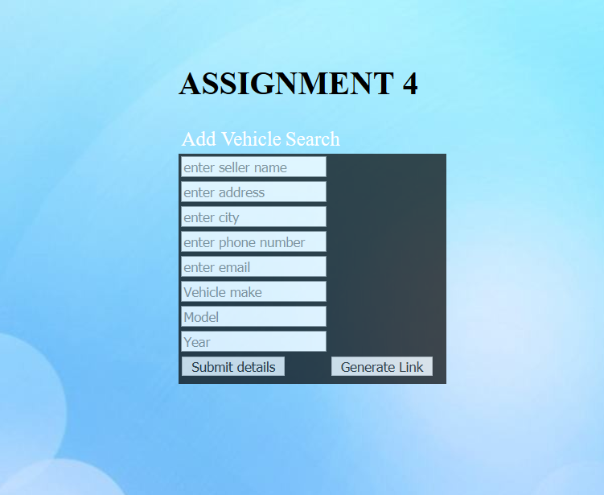

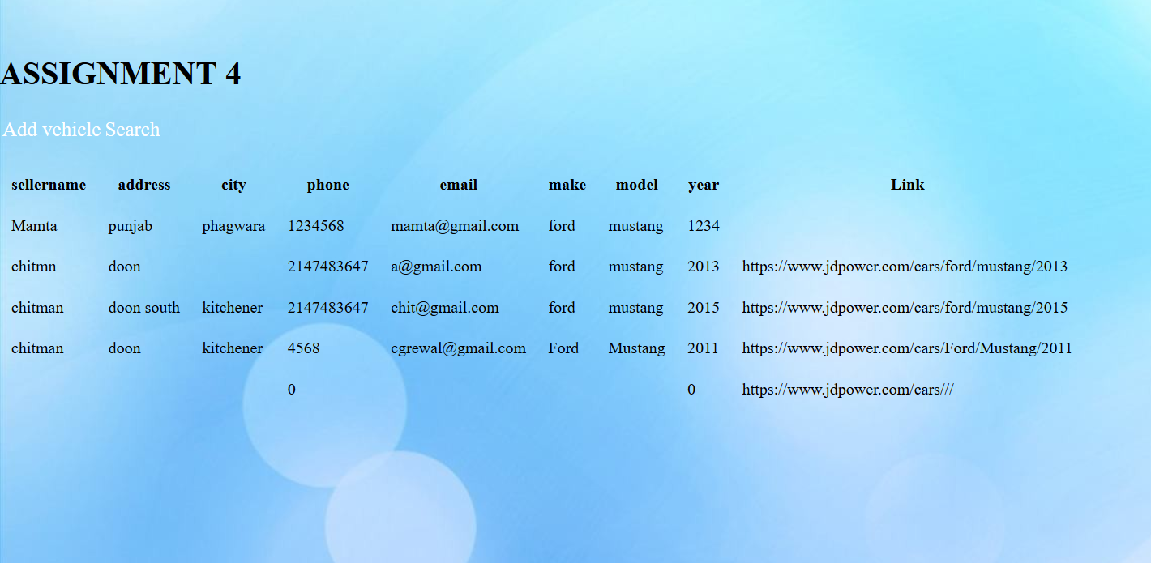

**Fields validations:**

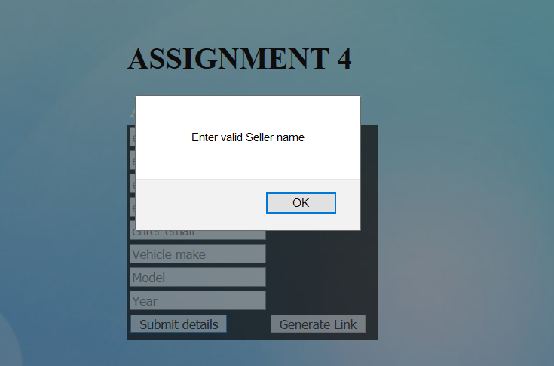

**Screen shot of NUnit:**

